**CSE 3241 Project Checkpoint 01 – Entities and Relationships**

Names: Group 08 Han Han, Tongshuai Zhang, Lance Chen, Yuliang Fu Date: 09/19/2018

In a **NEATLY TYPED** document, provide the following:

1. Based on the requirements given in the project overview, list the entities to be modeled in this database. For each entity, provide a list of associated attributes. Entities & Attributes

* **AUTHOR: Name,**
* **BOOK : ISBN , Title, Price, Year**
* **PUBLISHER: PName, URL, Address**
* **CATEGORY: Type**

1. Based on the requirements given in the project overview, what are the various relationships between entities? (For example, “CUSTOMER entities purchase BOOK entities”). …Relationships

* **PUBLISHER entities publish BOOK entities.**
* **BOOK entities belong to CATEGORY entities.**
* **AUTHOR entities write BOOK entities.**

1. Propose at least two additional entities that it would be useful for this database to model beyond the scope of the project requirements. Provide a list of possible attributes for the additional entities and possible relationships they may have with each other and the rest of the entities in the database. Give a brief, one sentence rationale for why adding these entities would be interesting/useful to the stakeholders for this database project. …you need to extend the data beyond what is in the sample Excel data file. Introduce new Entities & Relationships. Expand upon the data.

* **LANGUAGE: Type, Formality**
* **CONDITION: Degree**
* **WAREHOUSE: Address, Rent, Zip code, Space**
* **BOOK entities are written in LANGUAGE entities.**
* **BOOK entities are in FORMAT entities.**
* **BOOK entities are stored in WAREHOUSE entities.**

***Rationale***

* **The warehouse entity directly decides the operating cost of the bookstore since efficient WAREHOUSE management structure can reduce the cost and the other two additional entities mainly improve the user-experience increasing the profit of the stakeholders, which is the most interesting and useful point for the stakeholders.**

1. Give at least four examples of some informal queries/reports that it might be useful for this database might be used to generate. Include one example for each of the additional entities you proposed in question 3 above. …QUERTIES/REPORTS

* **SELECT a book whose ISBN is xxxxxxxxxx in the BOOK entities.**
* **PICK the Chinese as the language type for the book from LANGUAGE entities.**
* **STORE a BOOK at WAREHOUSE where the Address is xxxxx.**
* **BUY a used book from CONDITION entities.**

1. Suppose we want to add a new publisher to the database. How would we do that given the entities and relationships you’ve outlined above? Given your above description, is it possible to add a new publisher to your database without knowing the title of any books they have published? If not, revise your model to allow for publishers to be added as separate entities. …How is the data maintained? Inserts and updates…

**Method: Based on our assumptions and discussion, we can directly add the new publisher object to the PUBLISHER entities.**

**Practicability: As we let the relationship between the PUBLISHER entities and BOOK entities is a partial participation M(means the PUBLISHER can publishes 0 books )in the ER diagram, so the assumption of this circumstance is consistent with our ER diagram structure. Therefore, we do not need to revise our model.**

1. Determine at least three other informal update operations and describe what entities would need to have attributes altered and how they would need to be changed given your above descriptions. Include one example for each of the additional entities you proposed in question 3 above. …More update operations

* **Update the address attribute to the new address on the PUBLISHER entity, we can directly change the String value of the old one to the new one.**
* **Add one more category for the Type attribute on the CATEGORY entity, we can directly add “&” sign and the new CATOGORY name to update the old type value(this attribute data type should also be String). Like change ”computer & mathematics” to ”computer & mathematics &statistics”.**
* **Update the old-new condition value for the Degree attribute on the CONDITION entity, we can similarly update its value like ”new” to “nearly new”.**
* **Update the value of the formality attribute on the LANGUAGE entity. For example, change the old-fashioned language to the new type of language with the development of the society and language standards in the different situations.**

1. 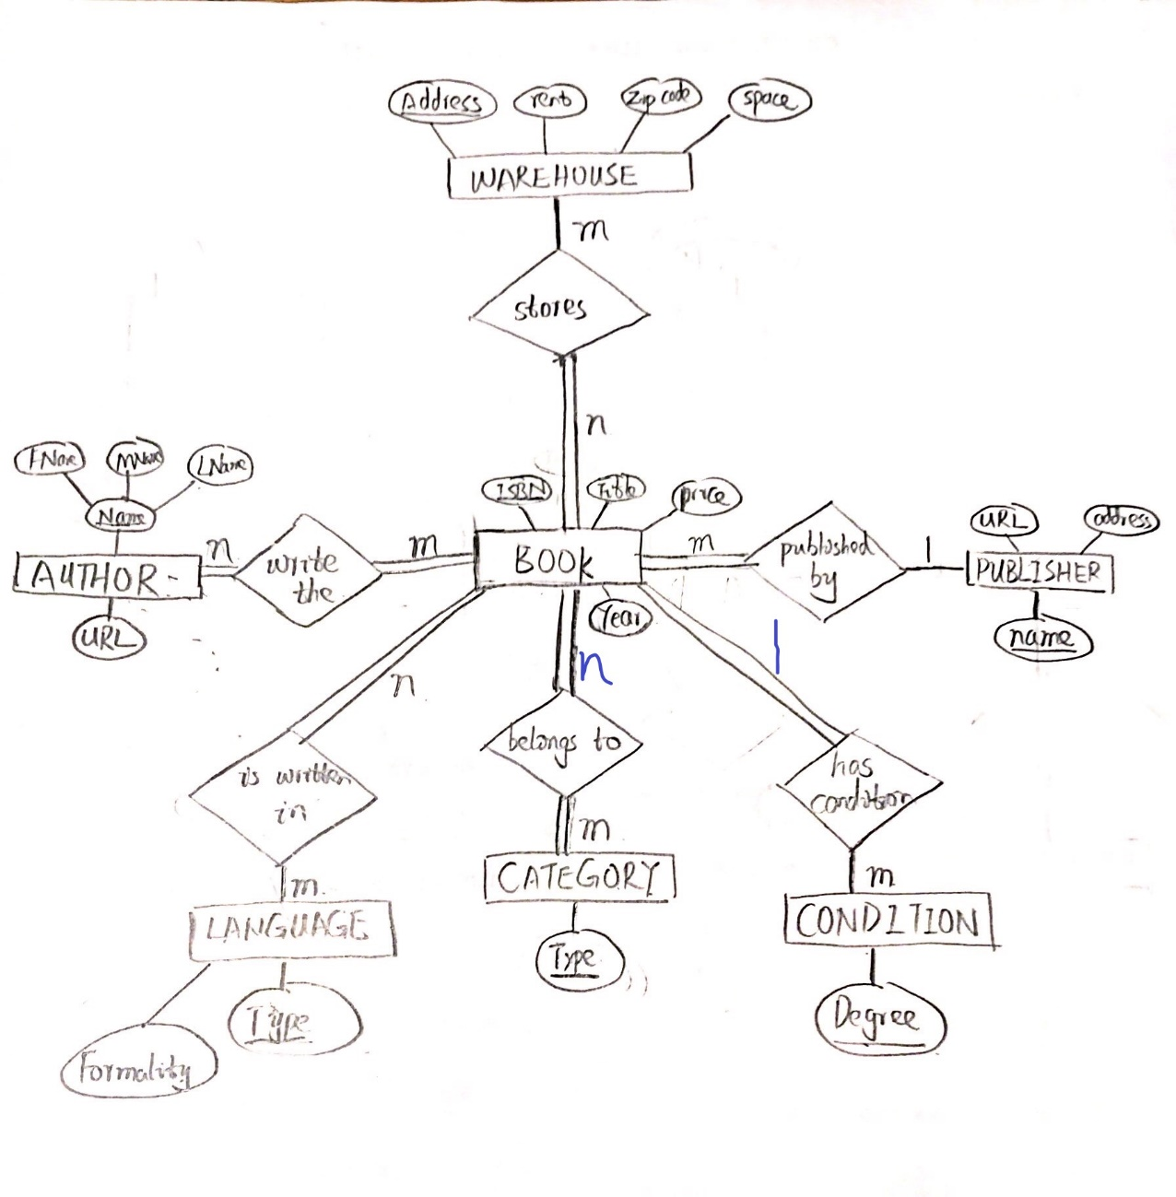Provide an ER diagram for your database. Make sure you include all of the entities and relationships you determined in the questions above ***INCLUDING the entities for question 3 above*** and remember that ***EVERY*** entity in your model needs to connect to another entity in the model via some kind of relationship. …ERD